SecurityMan DIY Smart Wireless Home Alarm System
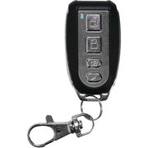

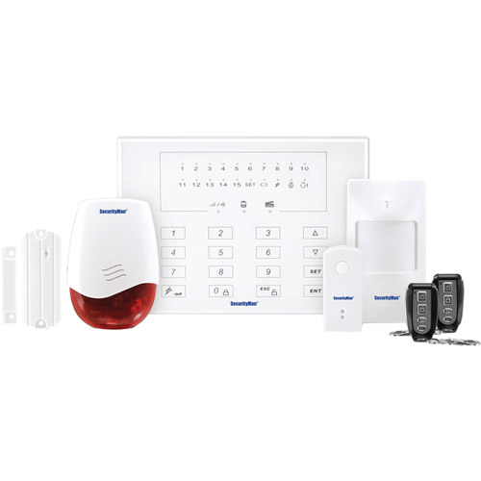
Details

Item Description
The SecurityMan DIY Smart Wireless Home Alarm System Kit is a wireless LED touchpad security alarm system kit with doorbell for home and business. It is user-friendly and easy to use, protecting your home/business at a minimum cost of investment. Do-It-Yourself installation and monitoring alarm system without monthly fees is a key benefit, and the system will alert you by phone through a series of enlisted phone numbers. You can then dial into the host to arm or disarm using the phone's numeric keypad. The SecurityMan DIY Smart Wireless Home Alarm System Kit can be upgraded by adding up to 60 wireless sensors, sirens and up to 10 remote controllers.
SecurityMan DIY Smart Wireless Home Alarm System Kit:
- Do-it-yourself wireless intruder alarm system kit
- This Wireless Home Security Alarm System Kit supports up to 60 wireless sensors and 5 phone numbers for auto alarm call
- Arm/disarm by remote controller, phone call or host keypad
- Internal rechargeable backup battery in alarm host lasts up to 16 hours
- Smart 3 defense lines configuration
- Land line disconnection alarm sound every 5 seconds
- Wireless Alarm System Kit includes:
  - Main host with LED and touch pad
  - PIR motion sensor
  - Smart door/window sensor
  - 2 remote controllers with panic button
  - Doorbell
  - Security warning sign
- 1-year warranty

Specifications
Battery Type: | Does Not Contain a Battery
Multi Pack Indicator: | No
Model No.: | AIR-ALARMII
Shipping Weight (in pounds): | 2.55
Product in Inches (L x W x H): | 3.0 x 14.0 x 11.0  Price $185.00 @walmart  Mace security systems $150.00 get items separate  I bought the mace security system about a month ago,I hooked it up in less than an hour.Pretty easy instructions to follow,it comes with one door/window sensor and one motion sensor,and 1 keychain remote,i hooked up the door/window sensor with no problems,i dont have any use for the motion sensor,would have been nice to have 2 door/window sensors,I have bought 2 more door/window sensors since then and they are very easy to sync up with the base unit,the local alarm on the sensor units themselves are not very loud but the main alarm is quite loud.If wanting to buy addtional sensors,i would buy off of wal-mart.com or ebay,do not order directly from the mace website,they charge double if not more than that per sensor.Also,programming is quite simple and if the alarm is activated in can call up to 5 numbers,this option works very quickly,about 30 seconds after alarm i get a call right on my cell phone,pretty nice.I work graveyard and this gives me a piece of mind when my wife and kids are home and i am at work.I would recommend this product.(hide full review)  Secure your home from theft and burglary with the Mace Wireless Home Security System. This easy-to-install system can store up to 5 phone numbers and has advanced motion detectors. Affixed to your home the door and window sensors detect motion, and activate the alarm and call your phone and additional emergency contact numbers upon detection. It activates the when triggered by opening of door or window. The wireless door security system is compatible with 14 different wireless accessories including a remote control featuring a panic button. The remote control helps in arming and disarming the security system easily. The alarm door system comes with A/C adapter for continuous power supply, and also includes a set of batteries that supplies charge in case of power cuts.  Mace Wireless Home Security System  • Detects motion or a door or window opening  • Activates an alarm, and calls up to 5 numbers  • Remote control with panic button feature  • Compatible with up to 14 additional wireless accessories for expansion  • Includes batteries and A/C adapter  Secure your home from theft and burglary with the Mace Wireless Home Security System. This easy-to-install system can store up to 5 phone numbers and has advanced motion detectors. Affixed to your home the door and window sensors detect motion, and activate the alarm and call your phone and additional emergency contact numbers upon detection. It activates the when triggered by opening of door or window. The wireless door security system is compatible with 14 different wireless accessories including a remote control featuring a panic button. The remote control helps in arming and disarming the security system easily. The alarm door system comes with A/C adapter for continuous power supply, and also includes a set of batteries that supplies charge in case of power cuts.  Mace Wireless Home Security System  • Detects motion or a door or window opening  • Activates an alarm, and calls up to 5 numbers  • Remote control with panic button feature  • Compatible with up to 14 additional wireless accessories for expansion  • Includes batteries and A/C adapter  A product better than expected.  04/09/2009  Easy to install, good price (lower than the factory), expandable (up to 14 sensors), reliable (tested many times, and no false alarm till now).  For a system of a professional security co., when alarm triggered they'll call you to ask if you are home or need they call the police. The Mace system can call you then you can choose from 1. listen through the phone to hear what's happening; 2. use the phone to warn the intruder with the loud-speaker of the Mace system; 3. or call the police, your neighbor....just the same, no matter you get the information from a security co such as ADT or from a DIY system such as Mace. So if we can do it by ourselves, easy and cheaper, why should we pay monthly charges?  Highly recommend. Have bought extra sensors from Wal Mart to expand the system.(hide full review)  Very good product  11/03/2009  I have to admit that I was a bit sceptical at first, but after installing the system (5 motion sensors and one door sensor) it works better than I imagined!  The fact it calls me on my telephone first and then the other 4 numbers I programed makes it a plus.  I have a door sensor at least 300 feet from the control panel and it doesn't have any issues.  Improvements would be to have a backlight on the LCD screen, because it's somewhat difficult to see, and on off button on the motion sensors. I simply pull the battery out of my bedroom sensor when I want to turn the system on at night while I'm sleeping.  Would be nice to have two remotes instead of the one they send, but I was impressed by the range of the remote.  I really don't think anyone could go wrong, it's a good buy  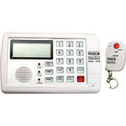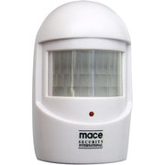  motion sensor $22.00  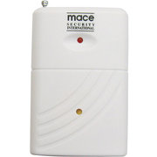 wireless window/ door sensor $21.00

GE 51107 Alarm System
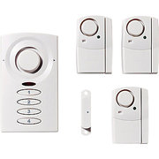

Item Description
Safeguard your house with the GE 51107 Alarm System. It comprises a door alarm and 3 window alarms that are very easy to setup and use. The wireless design is very hassle free and the 4-digit keypad that lets you set security code further enhances security. The 120 decibel alarm gives out warning tones when someone tries to break in or even when kids try to sneak out during the middle of the night. Operating on 3 AAA batteries, the door alarm also features an alarm delay feature while the 3 window alarms run on 4 LR44 batteries each. This GE alarm system is a great product to make your home more secure.
GE 51107 120 Decibel Home Alarm System:
• Easy to Install - No Wiring Necessary
• Door Alarm Uses 4-Digit Keypad to Set Security Code for Arming/Disarming
• Door Alarm Delay Feature to Avoid False Triggering
• 3-Window Alarms Included
• All Alarms are 120 Decibel
• Door Alarm Requires 3 AAA Batteries (Not Included)
• Each Window Alarm Requires 4 LR44 Batteries (Included)

Specifications
Model No.: | 51107
Shipping Weight (in pounds): | 0.61
Product in Inches (L x W x H):  Swann Window and Door Magnetic Alarms, SW351-MD2: 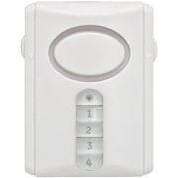 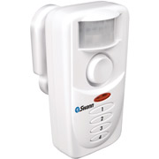 | 1.183 x 2.751 x 3.5535
Walmart No.: | 001174873
Swann Window and Door Magnetic Alarms (model SW351-MD2) can be used to protect a home, apartment or small business. This Magnetic Window Alarm is designed to protect your property whether you are away or at home. Installation is peel-and-stick: simply mount the Swann Window and Door Magnetic Alarms (model SW351-MD2) on a window with the included double-sided adhesive. This Door and Window Alarm will let you know if your property is being compromised by intruders. You can also install one on your door with these Magnetic Door Alarms in a 2pk. Swann Window and Door Magnetic Alarms (model SW351-MD2) are battery powered and 100 percent wireless.
Swann Window and Door Magnetic Alarms, SW351-MD2:
- Hassle-free installation
- Battery powered
- Totally wireless
- On/off switch
- Includes double-sided adhesive and two alarms
The Swann Keypad Alarm with Programmable Indoor Siren, SW351-KCH, is designed for consumers who want to feel secure at home. This keypad alarm will also provide peace of mind because you will know your property is being protected when you are away from home. The motion alarm is easy to install. You can do it yourself and show members of your family how simple it is to operate. The Swann alarm, when placed at secured entrances throughout your home, will sound an audible alert or alarm to let you know if attempts to gain access. When you install the Swann Keypad Alarm with Programmable Indoor Siren, SW351-KCH, you will have access to the code that is needed to set or turn off the alarm. You can share this information with whoever you choose. A keypad alarm will help to deter any thieves or burglars who are attempting to gain access to your property.
The compact design of the Swann Keypad Alarm with Programmable Indoor Siren allows you to install the unit where it is most convenient.
Swann Keypad Alarm with Programmable Indoor Siren, SW351-KCH:
- Add security without the high-priced hassle of a big monitored system
- Do-it-yourself, easy to install
- Alerts anyone attempting to come through a secured entrance
- Audible alarm
- Compact design

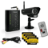
Defender system with dvr recording @ $200.00

This versatile DEFENDER Digital Wireless DVR Security System can be used to monitor and record video and audio in any indoor or outdoor space at any time of the day. Easy to set-up, this wireless plug and play system includes a 2GB SD card that can record up to 350 minutes of continuous audio and video footage. The weather resistant camera has 18 infrared LEDs that allow you to see up to 40' away in the dark. Connect to a television using the included A/V cable, and see and hear footage or live feed onscreen. Ideal for monitoring entrances, backyards, valuables and even employees, this DEFENDER Digital Wireless DVR Security System can be used in any situation you need.
DEFENDER Digital Wireless DVR Security System with Receiver:
- Digital wireless technology makes set up hassle-free
- DEFENDER DVR Security System Recording Capacity: 2GB
- Night vision up to 40' with 18 infrared LEDs
- Easily connects to a TV with included 6' AV cable
- Weather resistant camera
- Expandable system can support up to 4 cameras
- Motion detection settings
- 24 hour scheduled recording
- Remote control access
- DEFENDER Security System with Receiver Includes: 1x camera, 1x AV cable, 1x memory card, 1x receiver, 1x remote and 4 stickers
Do you have questions about this product? Ask a question.

From the Manufacturer
Is the information in this section helpful? Yes / No

Digital Wireless DVR Security System with Receiver
- Defender's PHOENIX 301 system can be used to monitor and record video and audio in any indoor or outdoor space at any time of the day. This wireless plug and play system allows for easy set up in a matter of minutes and the included 2GB SD card can record up to 350 minutes of continuous audio and video footage. The wireless, weather resistant camera included with this system has 18 infrared LEDs that allow you to see up to 40ft away in the dark. This system includes a compact receiver that easily connects to any television in your home or business using the included A/V cable. Ideal for monitoring entrances, backyards, valuables and employees, this PHOENIX 301 system can be used in any situation you need.
- 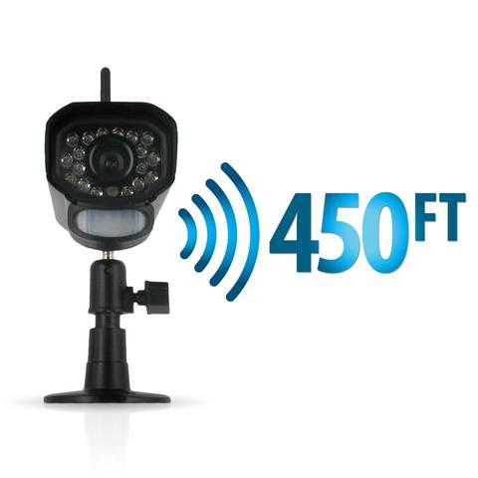

Digital Wireless Technology
The PHOENIX 301 series comes equipped with Digital Wireless Technology that ensures there is no messy wiring involved when setting the system up. This advanced system automatically connects on its own so you will be watching clear, interference-free footage in a matter of seconds. Superior digital functionality ensures that the signals passing between the camera and receiver remain strong as you monitor your business or home wirelessly, up to 450ft away.

SD Card Recording
Feel comforted knowing you can check if anyone was on your property when you were not there. This system includes a 2GB SD card that can capture up to 350 minutes of footage and audio. You have the option to continuously record, record only when motion is detected or set a schedule to record only during certain times of the day.
- 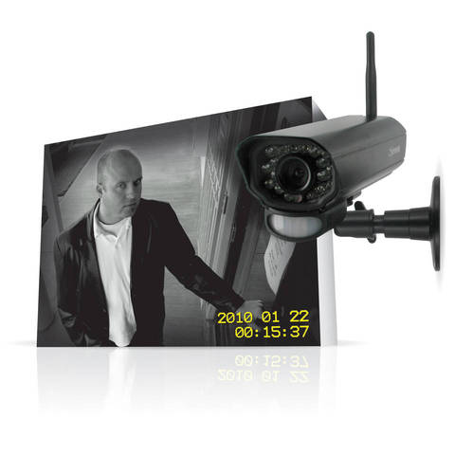

Long Range Night Vision
The indoor/outdoor camera provides you with a clear, secure picture, even when you monitor after-hours or in a dark location. The camera comes equipped with advanced night vision and 18 infrared (IR) LEDs that let you see clearly in the dark, up to 40ft away! The LEDs activate automatically when it gets dark, and deactivate during the day to save energy (CDS sensor). With this system, you can rest assured, knowing that you will have around the clock protection.

Easily Connects to a TV
This system can support an external TV/monitor with RCA connections. Connect your receiver to any television in your home or business with the included 6ft AV cable and experience the convenience of watching your live or recorded video on any screen size of your choice.
- 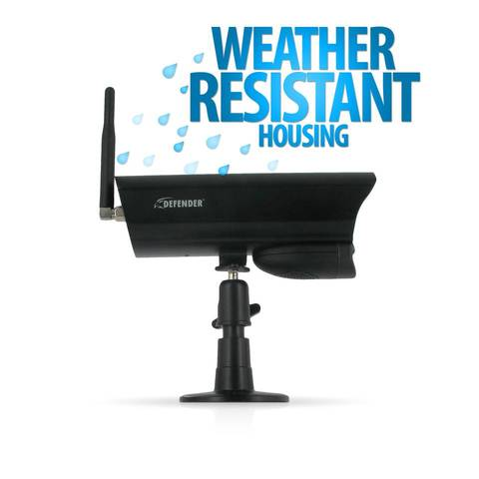

Indoor/Outdoor Wireless Camera
The included indoor/outdoor wireless color camera provides you with clear, crisp and enhanced video. Built for indoor or outdoor use, the camera's durable aluminum housing resists rusting, deterioration and can weather any season. The attached sun shield helps prevent glare from the sun and other bright objects. The camera also has a built in motion sensor so that you can be sure you will always be alerted when motion is detected.
- 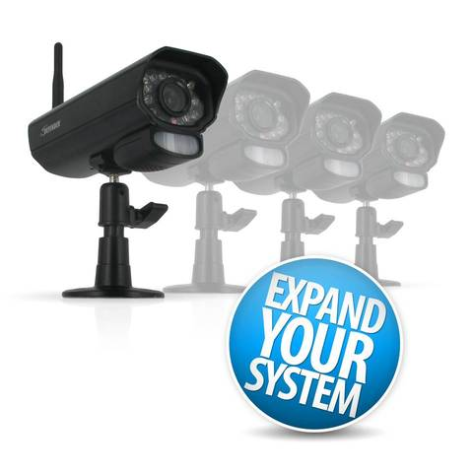

Expandable up to 4 Cameras
The PHOENIX 301 series allows you to easily secure several vulnerable spots on your property. This system can support a total of 4 cameras so you can monitor multiple offices, entrances and other outdoor areas. The compatible camera is Defender's Model # PX301-C. (Recording in quad mode not supported.)
- 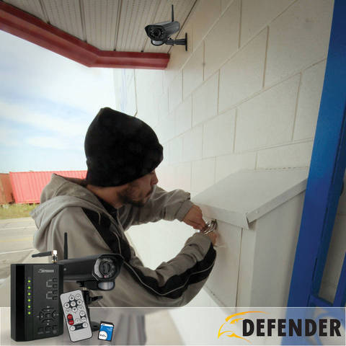

Motion Detection Settings
Motion settings give you flexibility so you can choose when the unit will start recording. You have many options, such as recording only when movement is detected. Using these easy to adjust settings will conserve your SD memory space so you can monitor longer. Simply turn on the motion recording and when the camera detects movement, the unit will begin recording. You can even set the system to sound an audible alert to notify you that motion is being detected.

24 Hour Scheduled Recording
Set up your preferred scheduled recording time throughout a 24-hour day. Record during peak business hours or record when you are not home so you will never miss a thing. This system allows you to record video footage using three different types of recording modes: manual, scheduled, and motion activation.
- 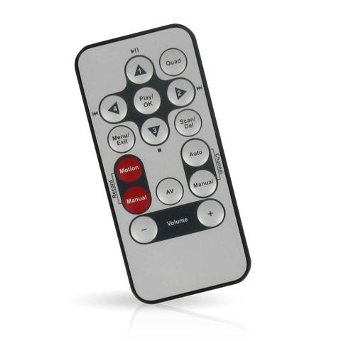

Remote Control Access
Control your system directly from the buttons on the receiver or from a distance with the included remote control. This system also comes equipped with an IR extension wire which allows your remote control to reach further and makes your system even more user friendly.
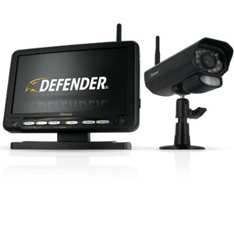

• • 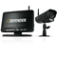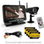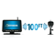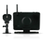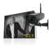
•
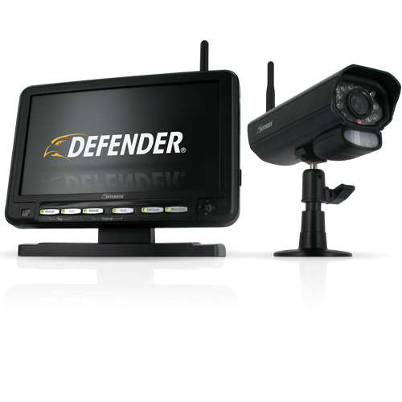
Details
Find In Store

Item Description
Keep an eye on your home or business round-the-clock with the Defender Indoor/Outdoor Wireless Security System.
Defender Indoor/Outdoor Digital Wireless DVR Security System with 7" LCD Monitor:
- The Defender Indoor/Outdoor Wireless Security System digital wireless technology remains strong up to 100' away
- Communicate with visitors or employees from a distance using the 2-way intercom
- Includes a 2GB SD card that can capture up to 350 minutes of footage and audio
- The Defender Digital Wireless DVR Security System with 7" LCD Monitor camera comes equipped with advanced night vision and 18 IR LEDs that let you see clearly in the dark, up to 40' away
- Motion settings give you flexibility to choose when the unit will start recording
- Indoor/outdoor wireless color camera provides you with clear, crisp and enhanced video
- Setup your preferred scheduled recording time throughout a 24-hour day
- Supports a total of 4 cameras so you can monitor multiple offices, entrances and other outdoor areas
- Review your footage easily on the 7" LCD monitor
- Control your system directly from the monitor's joystick or from a distance with the included remote
- Connect to a television using the included AV wire
- Defender DVR Security System Includes: AV cable, camera, memory card, monitor and remote

Specifications
Battery Type: | Does Not Contain a Battery
Multi Pack Indicator: | No
Model No.: | PX301-010
Shipping Weight (in pounds): | 3.55
Product in Inches (L x W x H): | 4.25 x 3.0 x 0.75
Walmart No.: | 551224831

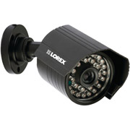Lorex Sg7570ab Super Resolution Weatherproof Indoor/Outdoor Camera with Microphone
$116.00
Reviews:
I bought this camera about a month ago. I placed it 300 feet outside my house to monitor my driveway. The camera works perfect, picks up the signal great, has a good picture, and is waterproof. My other camera's are wired and the picture on this wireless one is better than the wired camera's. I would highly recommend this item.
Nice camera for the price
06/14/2012
I bought a First Alert 4 camera system with DVR from another store a few weeks ago. The 4 cameras were wired but I needed a wireless camera for our attached garage. First Alert had one but it was kind of expensive so I started looking around and found this model of Lorex. The camera still needs a power source but it is wireless to the receiver, not a big deal for my particular set up. I am still trying the camera in some different spot before I mount it but this wireless camera has a much better picture as far as clarity in both day and night than the wired First Alert cameras on my system. The night vision is far superior.
The only thing that I dislike about the camera is the frame rate is choppy, even with 4 bars on the signal meter but it does say the frame rate on the camera is only 12. That seems a little low but as I stated above, the camera still has a better pic than the wired cameras I have. I can live with a little choppiness.
The other dislike is the location of the antenna. It is on top of the camera and can be rotated a little but if you are trying to mount the camera under an eve, it gets in the way and also reduces the reception to the receiver.
Right now, I just have the DVR sitting on our fireplace mantel and it so happens that it has a line of sight to the camera through a window. It will be interesting to see what happens once I move the DVR to a closet or the basement and it has more walls the signal has to go through.
So with the exception of the frame rate, this is a very good camera for the price

e information in this section helpful? Yes / No
More Information
- CLOSER LOOK: Digital Wireless Cameras

OVERVIEW
- 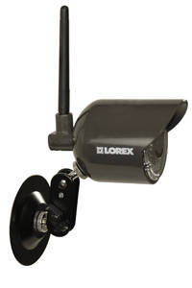

Wireless freedom
Experience the freedom and flexibility of wireless surveillance with the Lorex LIVE LW2110 Series Digital Wireless Security Camera. The camera can be used indoors or outdoors and provide clear video at any time of the day or night. With no video extension cables to run, you can place the cameras almost anywhere and change the location at any time.
The built-in infrared cut-filter delivers accurate color reproduction in all lighting conditions. At night-time, the picture changes to black & white for higher contrast and clarity. View video instantly on your TV, or connect the wireless micro-receivers to a security DVR for recording.
The high-gain wireless antenna can be angled between 90 and 180-degrees for easy installation beneath ceilings and eaves troughs to optimize the wireless range. Rest easy knowing that the digital wireless signal with FHSS technology is private, secure, and can't be picked up by any neighbors.
- Ideal for homes, small businesses, renters, hobbyists, or collectors, the LW2110 Series Digital Wireless Security Cameras let you keep an eye on what matters most to you. View your world with confidence. View your world with Lorex.

FEATURES
- 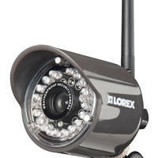

Indoor/Outdoor Digital Wireless Cameras
  - VGA resolution (640x480 @ 12FPS)
  - Lens: 5.1mm, F2.8 with 48° FOV
  - Simple installation. No video cable required¹
  - True day/night operation using integrated automatic Infrared Cut Filter (ICR) ensures accurate color representation in all lighting conditions
  - Connect multiple receivers to your surveillance recorder (DVR) to create a wireless surveillance solution²
  - 3ft BNC extension cable provided with each camera
  - Wireless micro-receiver plugs directly to the back of surveillance DVR
  - Night vision range up to 60ft (18m)³
  - Weatherproof design: ideal for outdoor & indoor applications (IP66)⁴
  - Outdoor wireless range of up to 450ft/137m; Indoor wireless range of up to 150ft/23m [With clear line-of-sight. Dense objects and materials, such as trees, concrete, and brick may impact signal range]⁵
  - High-gain antenna ensures improved long distance operation
  - Out-of-Range alert
  - Ceiling, wall, or counter mountable with the included versatile 3D Flex stand & mounting hardware
  - Power consumption: 200mA, 12V DC

Wireless Disclaimers
1. Camera requires a wired connection to a power outlet. Power adapter included.
2. Using multiple receivers in close proximity to each other may cause a slight slowdown in frame rate performance. Try to maintain at least a few inches of space between each receiver. 3ft extension cable included.
3. Stated IR Illumination range is based on ideal conditions. Actual range and image clarity depends on installation location, viewing area and light reflection/absorption level of object.
4. Not intended for submersion in water. Installation in a sheltered area recommended.
5. Maximum wireless transmission range. Actual range dependent upon building materials and other obstructions in path of wireless signal.

SPECIFICATIONS
- 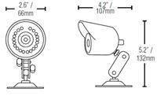

Camera and receiver
  - Image Sensor: 1/4" Color AIS (Advanced Image Sensor)
  - Video Format: NTSC
  - Effective Pixels: H: 656, V: 492
  - Resolution: 480 TV Line
  - Scan System: 2:1 Interlaced
  - Sync System: Internal
  - S/N Ratio: More than 48dB
  - Iris: AES
  - AES Shutter Speed: 1/60~1/50,000 Sec
  - Mini Illumination: 0.6 Lux without IR LED, 0 Lux with IR LED
  - Video Output: 1.0Vpp @ 75 ohm
  - Lens/ Lens Mount: 5.1mm F2.8/ Fixed
  - Field Of View (Diagonal): 48 degrees
  - Termination: BNC
  - IR LED/ Night Vision Range: 18 pieces /850 nm / 50ft/15m
  - Power Requirement: 12V DC ±10%
  - Power Consumption: Max 250 mA (w/ IR), Max 90mA (w/o IR)
  - Operating Temp Range: 14° ~ 122°F / -10° ~ 50° C
  - Environmental Rating: IP 66
  - Dimensions (with stand): 2.6"x4.2"x5.2" (WxDxH)

IN THE BOX
- 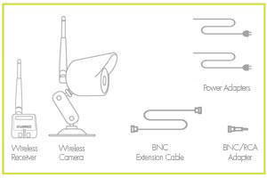
  - Digital Wireless Camera¹
  - Digital wireless micro-receiver²
  - Camera power adapter (CEC compliant)²
  - Mounting kit³
  - 3ft BNC extension cable³
  - BNC/RCA adapter³
  - Easy Installation Quick Start Guide

Disclaimers
1. Number of included cameras varies by model number.
2. One micro-receiver power adapter included. 2-camera pack includes one 2-in-1 power adapter to power both micro-receivers.
3. Number of included accessories varies by model number

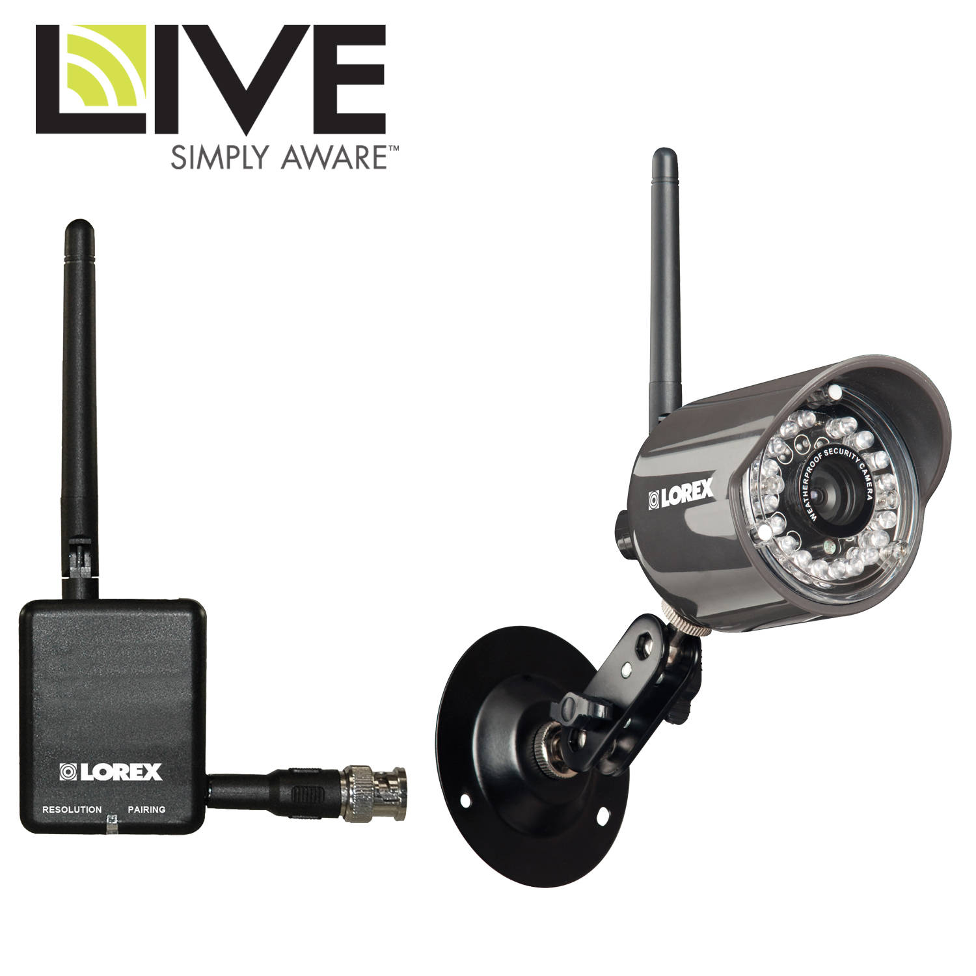Market Analysis Summary
PC Repair will provide computer support in both a consulting and technical capacity to small business owners as well as home PC users. Since PC Repair is currently a one man operation, its growth in the first three months will be limited by the owner's capacity to complete work. However, these first three months are critical for establishing our credibility and a reputation for getting the job done quickly and well. We will focus on delivering excellent service, and using the good word of mouth from this initial period to network with other potential clients.
Personal market research by the owner indicates an attractive market niche for our services, of which PC Repair will take full advantage. The very nature of the computing industry, with its extraordinary rate of technological development, creates a constant need for businesses skilled in updating and advising customers on computer-related issues.
National chains, such as "Geeks on Call," and Best Buy's "Geek Squad" have seen rapid growth in demand for these services in the last few years. Customers are seeking skilled help with everything from installation of software and hardware components, to networking, to transferring files from an old computer to a new one. Those who can often enlist their tech-savvy children's help, but others are not so fortunate, and small-business owners need reliable and quick help with all their computer needs, since every hour down may mean an hour or more of lost revenue, especially for any business with a website or those doing e-commerce.

4.1 Market Segmentation
The existing computer service market is so extensive that categorizing it is rather difficult. We have broken our potential market down into two groups, based on their needs: home PC users and small business clients.
Home PC User
Our home PC user market includes non-tech-savvy residents of the local area (15 mile radius), generally between the ages of 30 and 70, with at least one home computer. We are not expecting income from users below 30, who tend to be more comfortable with technology and willing to attempt repairs and upgrades on their own, without seeking professional assistance. Such home users generally own a computer to do email, play games, write letters, scan and print photos, and occasionally to do bookkeeping or taxes. Home PC users with more sophisticated applications generally have enough tech savvy, from tech experience at work, to do their own repairs and upgrades. Their hardware needs will include the computer itself, monitors, keyboards, mouse, printer, and scanner.
This group is growing slightly faster than the overall population growth in our area, in part due to the increasing demand for computers among retired people and young families, about 7% a year.
Small Business Users
Small business users will provide the majority of our business revenue. The small business market will be defined as customers within a 15 mile radius, with 2 or more computers or a network which they use for business purposes at least 25% of the time. Their business use may include minor usage, such as updating a business website for a brick-and-mortar store, keeping the books, designing graphics or ad campaigns, and writing copy for press releases. It may also be more extensive, incorporating inventory tracking, POS systems, customer databases, online product/service delivery, or product development. The more intensive their computer usage for business, the more critical it is to them that their technology work well and reliably, and that quality repairs and support are available in a crisis. Their hardware needs will include the same items as home users, plus servers, backup systems, data storage, and wireless networking.
The portion of the small business market we are targeting is growing at around 2% a year.

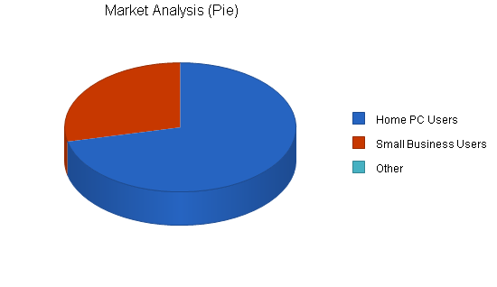

Need actual charts?
We recommend using LivePlan as the easiest way to create graphs for your own business plan.
Create your own business plan »
Market Analysis
 |  | Year 1 | Year 2 | Year 3 | Year 4 | Year 5
Potential Customers | Growth |  |  |  |  |  | CAGR
Home PC Users | 7% | 25,000 | 26,750 | 28,623 | 30,626 | 32,770 | 7.00%
Small Business Users | 2% | 10,000 | 10,100 | 10,201 | 10,303 | 10,406 | 1.00%
Other | 0% | 0 | 0 | 0 | 0 | 0 | 0.00%
Total | 5.39% | 35,000 | 36,850 | 38,824 | 40,929 | 43,176 | 5.39%

Need real financials?
We recommend using LivePlan as the easiest way to create automatic financials for your own business plan.
Create your own business plan »

4.2 Target Market Segment Strategy
Although there are more potential customers among home PC users, we expect the majority of our revenue to come from small business clients, since their need for our services is more urgent, and they are willing to invest in technology as part of their business plan. The majority of our marketing efforts will thus be focused on small business owners. These customers typically don't have a full-time IT person, but have full-time IT needs. Home PCs are often used by multiple people, and serve multiple purposes. Our home PC users need help with managing their settings to integrate the different needs of all household members as much as they need technical assistance.
ComputingNet magazine recently reported on the substantial need for timely and cost-effective computer upgrades and repairs in this region; Jack Hacker has seen this market need in person, as frustrated clients waited for days or weeks for their critical components to be returned to full capacity, with no inexpensive alternative to the existing computer repair shops. All of our clients need technical assistance, but we are also selling peace of mind: our clients will know that friendly, efficient help is just a phone call away. As more and more companies switch their support services to automated call centers or touch-tone menus, the simple reassurance of hearing another human voice on the phone within a few rings is immeasurable. Even better is knowing that within a few hours, someone will show up and take care of their problem.
Both the software and hardware side of the computer industry continue to turn out new and revised computer components at alarming rates. For PC Repair this means job security well into the future. As reported by the Wall Street Journal, there seems to be no end to the development of the computer market. Business Week expects the computing industry to grow at a rate of 12% and the processor speeds to continue to expand for years to come.

4.3 Service Business Analysis
Secondary market research shows computer service customers tend to be very loyal to providers that do good work and satisfy their needs. An analysis of PC Repair's main competitors shows no overwhelming strengths that would be significant barriers to entry into the market, as our local competitors have serious weaknesses.
The computer maintenance and repair industry is fragmented, with a few large, national players and hundreds of small, local stores. While most computers are actually repaired in-store, near the customer, parts for the repair come from major manufacturers and distributors; delays in receiving necessary parts can significantly slow down the repair process. Large chains have solved this problem by keeping vast amounts of inventory in stock at all times, while local stores offer customers the trade-off of personal interaction and trust that may make up for some delay.
PC Repair has established a relationship with a local distributor to do rapid special-ordering; although this capability is more expensive than normal channels, it will enable us to quickly establish a reputation as efficient and responsive to customer needs, particularly for our small business users. We will leverage this customer loyalty into great word of mouth marketing and steady growth.

4.3.1 Competition and Buying Patterns
Customers choose computer repair and assistance services based on reputation, previous experience, and price. They may choose to return to a mediocre provider with whom they're familiar, rather than try out a new unknown company about whom they've heard nothing. Large stores, especially the service departments of national chains, have a great advantage simply in their affiliation with an established brand. Establishing our brand identity and a great reputation in the first few months is critical to our success. Once we have broken in to the local market, our great service will turn new clients into permanent clients.
Our services will be second to no one and our prices will be very reasonable for the high quality service we offer. By providing superior service, word of mouth alone will bring in many new clients. The satisfaction our consumers find will keep them coming back. There are two main competitors for the computer upgrade and repair business in this area:
- Competitor A. They are a well established provider of computer upgrades and services, and do quick work. However, they have a high staff turnover, a young and inexperienced staff, and are more interested in selling new components than in maintaining existing machines or finding custom solutions. They do not offer any kind of pick-up and drop-off service, and do not offer on-site help. They really only offer hardware support.
- Competitor B. Smaller and less known then A, B provides many services for residents living in east and south parts of town. They are more willing to spend time with a client, figuring out exactly what his or her needs are, and suggesting new options than competitor A. However, they have an inefficient ordering system and an unkempt shop, which deters potential customers and can turn existing customers to the competition. They also do not offer on-site services, although they are considering instituting a trial pick-up/drop-off service. They are in the best position to copy our innovations and steal customers, but their management is complacent and may not respond to competition.
Both of these companies charge rates in excess of PC Repair; we will be able to attract the price-sensitive market without much work.
Read more: http://www.bplans.com/computer_repair_business_plan/market_analysis_summary_fc.php#ixzz2pZ8gIUlE

Market Analysis Summary
PC Repair will provide computer support in both a consulting and technical capacity to small business owners as well as home PC users. Since PC Repair is currently a one man operation, its growth in the first three months will be limited by the owner's capacity to complete work. However, these first three months are critical for establishing our credibility and a reputation for getting the job done quickly and well. We will focus on delivering excellent service, and using the good word of mouth from this initial period to network with other potential clients.
Personal market research by the owner indicates an attractive market niche for our services, of which PC Repair will take full advantage. The very nature of the computing industry, with its extraordinary rate of technological development, creates a constant need for businesses skilled in updating and advising customers on computer-related issues.
National chains, such as "Geeks on Call," and Best Buy's "Geek Squad" have seen rapid growth in demand for these services in the last few years. Customers are seeking skilled help with everything from installation of software and hardware components, to networking, to transferring files from an old computer to a new one. Those who can often enlist their tech-savvy children's help, but others are not so fortunate, and small-business owners need reliable and quick help with all their computer needs, since every hour down may mean an hour or more of lost revenue, especially for any business with a website or those doing e-commerce.

4.1 Market Segmentation
The existing computer service market is so extensive that categorizing it is rather difficult. We have broken our potential market down into two groups, based on their needs: home PC users and small business clients.
Home PC User
Our home PC user market includes non-tech-savvy residents of the local area (15 mile radius), generally between the ages of 30 and 70, with at least one home computer. We are not expecting income from users below 30, who tend to be more comfortable with technology and willing to attempt repairs and upgrades on their own, without seeking professional assistance. Such home users generally own a computer to do email, play games, write letters, scan and print photos, and occasionally to do bookkeeping or taxes. Home PC users with more sophisticated applications generally have enough tech savvy, from tech experience at work, to do their own repairs and upgrades. Their hardware needs will include the computer itself, monitors, keyboards, mouse, printer, and scanner.
This group is growing slightly faster than the overall population growth in our area, in part due to the increasing demand for computers among retired people and young families, about 7% a year.
Small Business Users
Small business users will provide the majority of our business revenue. The small business market will be defined as customers within a 15 mile radius, with 2 or more computers or a network which they use for business purposes at least 25% of the time. Their business use may include minor usage, such as updating a business website for a brick-and-mortar store, keeping the books, designing graphics or ad campaigns, and writing copy for press releases. It may also be more extensive, incorporating inventory tracking, POS systems, customer databases, online product/service delivery, or product development. The more intensive their computer usage for business, the more critical it is to them that their technology work well and reliably, and that quality repairs and support are available in a crisis. Their hardware needs will include the same items as home users, plus servers, backup systems, data storage, and wireless networking.
The portion of the small business market we are targeting is growing at around 2% a year.

Need actual charts?
We recommend using LivePlan as the easiest way to create graphs for your own business plan.
Create your own business plan »
Market Analysis
 |  | Year 1 | Year 2 | Year 3 | Year 4 | Year 5
Potential Customers | Growth |  |  |  |  |  | CAGR
Home PC Users | 7% | 25,000 | 26,750 | 28,623 | 30,626 | 32,770 | 7.00%
Small Business Users | 2% | 10,000 | 10,100 | 10,201 | 10,303 | 10,406 | 1.00%
Other | 0% | 0 | 0 | 0 | 0 | 0 | 0.00%
Total | 5.39% | 35,000 | 36,850 | 38,824 | 40,929 | 43,176 | 5.39%

Need real financials?
We recommend using LivePlan as the easiest way to create automatic financials for your own business plan.
Create your own business plan »

4.2 Target Market Segment Strategy
Although there are more potential customers among home PC users, we expect the majority of our revenue to come from small business clients, since their need for our services is more urgent, and they are willing to invest in technology as part of their business plan. The majority of our marketing efforts will thus be focused on small business owners. These customers typically don't have a full-time IT person, but have full-time IT needs. Home PCs are often used by multiple people, and serve multiple purposes. Our home PC users need help with managing their settings to integrate the different needs of all household members as much as they need technical assistance.
ComputingNet magazine recently reported on the substantial need for timely and cost-effective computer upgrades and repairs in this region; Jack Hacker has seen this market need in person, as frustrated clients waited for days or weeks for their critical components to be returned to full capacity, with no inexpensive alternative to the existing computer repair shops. All of our clients need technical assistance, but we are also selling peace of mind: our clients will know that friendly, efficient help is just a phone call away. As more and more companies switch their support services to automated call centers or touch-tone menus, the simple reassurance of hearing another human voice on the phone within a few rings is immeasurable. Even better is knowing that within a few hours, someone will show up and take care of their problem.
Both the software and hardware side of the computer industry continue to turn out new and revised computer components at alarming rates. For PC Repair this means job security well into the future. As reported by the Wall Street Journal, there seems to be no end to the development of the computer market. Business Week expects the computing industry to grow at a rate of 12% and the processor speeds to continue to expand for years to come.

4.3 Service Business Analysis
Secondary market research shows computer service customers tend to be very loyal to providers that do good work and satisfy their needs. An analysis of PC Repair's main competitors shows no overwhelming strengths that would be significant barriers to entry into the market, as our local competitors have serious weaknesses.
The computer maintenance and repair industry is fragmented, with a few large, national players and hundreds of small, local stores. While most computers are actually repaired in-store, near the customer, parts for the repair come from major manufacturers and distributors; delays in receiving necessary parts can significantly slow down the repair process. Large chains have solved this problem by keeping vast amounts of inventory in stock at all times, while local stores offer customers the trade-off of personal interaction and trust that may make up for some delay.
PC Repair has established a relationship with a local distributor to do rapid special-ordering; although this capability is more expensive than normal channels, it will enable us to quickly establish a reputation as efficient and responsive to customer needs, particularly for our small business users. We will leverage this customer loyalty into great word of mouth marketing and steady growth.

4.3.1 Competition and Buying Patterns
Customers choose computer repair and assistance services based on reputation, previous experience, and price. They may choose to return to a mediocre provider with whom they're familiar, rather than try out a new unknown company about whom they've heard nothing. Large stores, especially the service departments of national chains, have a great advantage simply in their affiliation with an established brand. Establishing our brand identity and a great reputation in the first few months is critical to our success. Once we have broken in to the local market, our great service will turn new clients into permanent clients.
Our services will be second to no one and our prices will be very reasonable for the high quality service we offer. By providing superior service, word of mouth alone will bring in many new clients. The satisfaction our consumers find will keep them coming back. There are two main competitors for the computer upgrade and repair business in this area:
- Competitor A. They are a well established provider of computer upgrades and services, and do quick work. However, they have a high staff turnover, a young and inexperienced staff, and are more interested in selling new components than in maintaining existing machines or finding custom solutions. They do not offer any kind of pick-up and drop-off service, and do not offer on-site help. They really only offer hardware support.
- Competitor B. Smaller and less known then A, B provides many services for residents living in east and south parts of town. They are more willing to spend time with a client, figuring out exactly what his or her needs are, and suggesting new options than competitor A. However, they have an inefficient ordering system and an unkempt shop, which deters potential customers and can turn existing customers to the competition. They also do not offer on-site services, although they are considering instituting a trial pick-up/drop-off service. They are in the best position to copy our innovations and steal customers, but their management is complacent and may not respond to competition.
Both of these companies charge rates in excess of PC Repair; we will be able to attract the price-sensitive market without much work.
Read more: http://www.bplans.com/computer_repair_business_plan/market_analysis_summary_fc.php#ixzz2pZ8gIUlE

Market Analysis Summary
PC Repair will provide computer support in both a consulting and technical capacity to small business owners as well as home PC users. Since PC Repair is currently a one man operation, its growth in the first three months will be limited by the owner's capacity to complete work. However, these first three months are critical for establishing our credibility and a reputation for getting the job done quickly and well. We will focus on delivering excellent service, and using the good word of mouth from this initial period to network with other potential clients.
Personal market research by the owner indicates an attractive market niche for our services, of which PC Repair will take full advantage. The very nature of the computing industry, with its extraordinary rate of technological development, creates a constant need for businesses skilled in updating and advising customers on computer-related issues.
National chains, such as "Geeks on Call," and Best Buy's "Geek Squad" have seen rapid growth in demand for these services in the last few years. Customers are seeking skilled help with everything from installation of software and hardware components, to networking, to transferring files from an old computer to a new one. Those who can often enlist their tech-savvy children's help, but others are not so fortunate, and small-business owners need reliable and quick help with all their computer needs, since every hour down may mean an hour or more of lost revenue, especially for any business with a website or those doing e-commerce.

4.1 Market Segmentation
The existing computer service market is so extensive that categorizing it is rather difficult. We have broken our potential market down into two groups, based on their needs: home PC users and small business clients.
Home PC User
Our home PC user market includes non-tech-savvy residents of the local area (15 mile radius), generally between the ages of 30 and 70, with at least one home computer. We are not expecting income from users below 30, who tend to be more comfortable with technology and willing to attempt repairs and upgrades on their own, without seeking professional assistance. Such home users generally own a computer to do email, play games, write letters, scan and print photos, and occasionally to do bookkeeping or taxes. Home PC users with more sophisticated applications generally have enough tech savvy, from tech experience at work, to do their own repairs and upgrades. Their hardware needs will include the computer itself, monitors, keyboards, mouse, printer, and scanner.
This group is growing slightly faster than the overall population growth in our area, in part due to the increasing demand for computers among retired people and young families, about 7% a year.
Small Business Users
Small business users will provide the majority of our business revenue. The small business market will be defined as customers within a 15 mile radius, with 2 or more computers or a network which they use for business purposes at least 25% of the time. Their business use may include minor usage, such as updating a business website for a brick-and-mortar store, keeping the books, designing graphics or ad campaigns, and writing copy for press releases. It may also be more extensive, incorporating inventory tracking, POS systems, customer databases, online product/service delivery, or product development. The more intensive their computer usage for business, the more critical it is to them that their technology work well and reliably, and that quality repairs and support are available in a crisis. Their hardware needs will include the same items as home users, plus servers, backup systems, data storage, and wireless networking.
The portion of the small business market we are targeting is growing at around 2% a year.

Need actual charts?
We recommend using LivePlan as the easiest way to create graphs for your own business plan.
Create your own business plan »
Market Analysis
 |  | Year 1 | Year 2 | Year 3 | Year 4 | Year 5
Potential Customers | Growth |  |  |  |  |  | CAGR
Home PC Users | 7% | 25,000 | 26,750 | 28,623 | 30,626 | 32,770 | 7.00%
Small Business Users | 2% | 10,000 | 10,100 | 10,201 | 10,303 | 10,406 | 1.00%
Other | 0% | 0 | 0 | 0 | 0 | 0 | 0.00%
Total | 5.39% | 35,000 | 36,850 | 38,824 | 40,929 | 43,176 | 5.39%

Need real financials?
We recommend using LivePlan as the easiest way to create automatic financials for your own business plan.
Create your own business plan »

4.2 Target Market Segment Strategy
Although there are more potential customers among home PC users, we expect the majority of our revenue to come from small business clients, since their need for our services is more urgent, and they are willing to invest in technology as part of their business plan. The majority of our marketing efforts will thus be focused on small business owners. These customers typically don't have a full-time IT person, but have full-time IT needs. Home PCs are often used by multiple people, and serve multiple purposes. Our home PC users need help with managing their settings to integrate the different needs of all household members as much as they need technical assistance.
ComputingNet magazine recently reported on the substantial need for timely and cost-effective computer upgrades and repairs in this region; Jack Hacker has seen this market need in person, as frustrated clients waited for days or weeks for their critical components to be returned to full capacity, with no inexpensive alternative to the existing computer repair shops. All of our clients need technical assistance, but we are also selling peace of mind: our clients will know that friendly, efficient help is just a phone call away. As more and more companies switch their support services to automated call centers or touch-tone menus, the simple reassurance of hearing another human voice on the phone within a few rings is immeasurable. Even better is knowing that within a few hours, someone will show up and take care of their problem.
Both the software and hardware side of the computer industry continue to turn out new and revised computer components at alarming rates. For PC Repair this means job security well into the future. As reported by the Wall Street Journal, there seems to be no end to the development of the computer market. Business Week expects the computing industry to grow at a rate of 12% and the processor speeds to continue to expand for years to come.

4.3 Service Business Analysis
Secondary market research shows computer service customers tend to be very loyal to providers that do good work and satisfy their needs. An analysis of PC Repair's main competitors shows no overwhelming strengths that would be significant barriers to entry into the market, as our local competitors have serious weaknesses.
The computer maintenance and repair industry is fragmented, with a few large, national players and hundreds of small, local stores. While most computers are actually repaired in-store, near the customer, parts for the repair come from major manufacturers and distributors; delays in receiving necessary parts can significantly slow down the repair process. Large chains have solved this problem by keeping vast amounts of inventory in stock at all times, while local stores offer customers the trade-off of personal interaction and trust that may make up for some delay.
PC Repair has established a relationship with a local distributor to do rapid special-ordering; although this capability is more expensive than normal channels, it will enable us to quickly establish a reputation as efficient and responsive to customer needs, particularly for our small business users. We will leverage this customer loyalty into great word of mouth marketing and steady growth.

4.3.1 Competition and Buying Patterns
Customers choose computer repair and assistance services based on reputation, previous experience, and price. They may choose to return to a mediocre provider with whom they're familiar, rather than try out a new unknown company about whom they've heard nothing. Large stores, especially the service departments of national chains, have a great advantage simply in their affiliation with an established brand. Establishing our brand identity and a great reputation in the first few months is critical to our success. Once we have broken in to the local market, our great service will turn new clients into permanent clients.
Our services will be second to no one and our prices will be very reasonable for the high quality service we offer. By providing superior service, word of mouth alone will bring in many new clients. The satisfaction our consumers find will keep them coming back. There are two main competitors for the computer upgrade and repair business in this area:
- Competitor A. They are a well established provider of computer upgrades and services, and do quick work. However, they have a high staff turnover, a young and inexperienced staff, and are more interested in selling new components than in maintaining existing machines or finding custom solutions. They do not offer any kind of pick-up and drop-off service, and do not offer on-site help. They really only offer hardware support.
- Competitor B. Smaller and less known then A, B provides many services for residents living in east and south parts of town. They are more willing to spend time with a client, figuring out exactly what his or her needs are, and suggesting new options than competitor A. However, they have an inefficient ordering system and an unkempt shop, which deters potential customers and can turn existing customers to the competition. They also do not offer on-site services, although they are considering instituting a trial pick-up/drop-off service. They are in the best position to copy our innovations and steal customers, but their management is complacent and may not respond to competition.
Both of these companies charge rates in excess of PC Repair; we will be able to attract the price-sensitive market without much work.
Read more: http://www.bplans.com/computer_repair_business_plan/market_analysis_summary_fc.php#ixzz2pZ8gIUlE

